Comparisons
Point to plane distance VS. Point to point distance
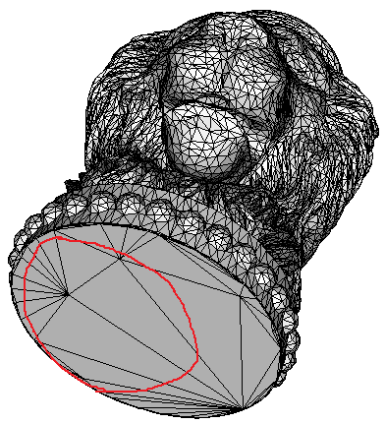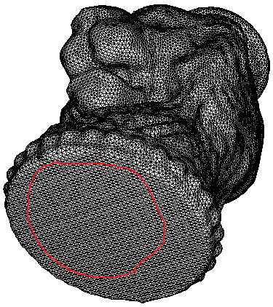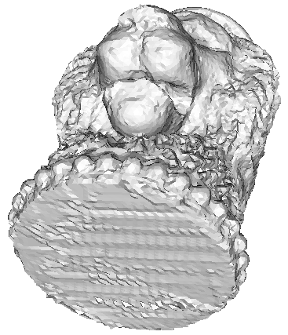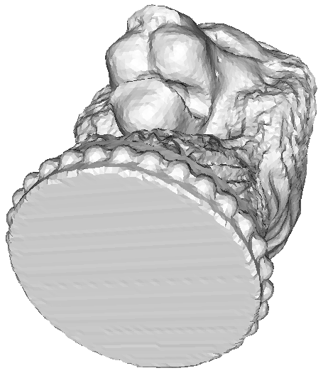
Original mesh Smoothed non-obtuse mesh point to plane distance point to point distance
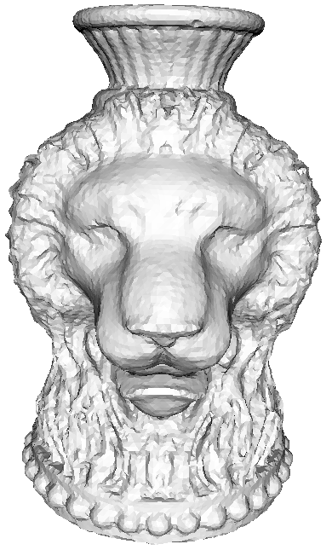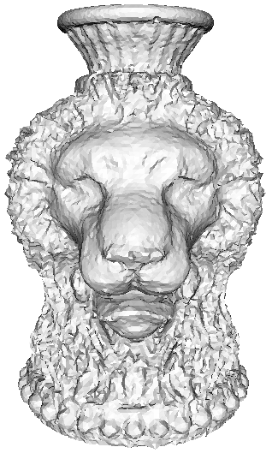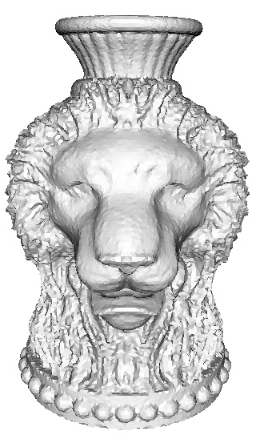
Point to point distance Point to plane distance Point to point (normal hitting)
1. Point to point distances: the approximated error is not satisfied, especially some triangles are without corresponding vertices from the smoothed non-obtuse mesh.
2. Point to plane distances: the approximated error is better than point to point distance, but if many vertices are corresponding to a same triangle, then the point to plane energies are the same, jagged surface would be induced.
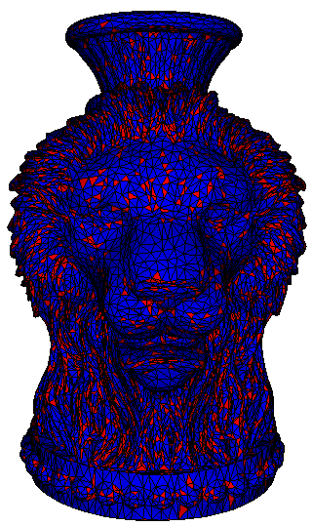
The red triangles are without corresponding vertex from the smoothed non-obtuse mesh (5697 triangles are red, 14033 triangles are blue).

